EENG 385 - Electronic Devices and Circuits

Lab 6 – Audio Board Buildup

Just Solutions

**LM7805**

1. What two things make the L7805 essentially indestructible?

**The L7805 has internal current limiting and thermal shutdown.**

1. Use TD-Figure 2 to name each of the 3 pins below. For example, A = GND, B = GND, C=GND. Clearly, this is not the correct answer.

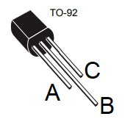

**A = pin 3 = Vin B = pin 2 = GND C = pin 1 = Vout**

1. Look at TD-Table 1, what is the absolute maximum input voltage for our regulator?

**For an output voltage between 3.3V to 9V, the maximum input voltage is 30V.**

1. Look at TD-Table 1, what is the absolute maximum output current for our regulator?

**The 7805 can deliver up to 100mA output current.**

1. The minimum difference between the input voltage and the output voltage is called the dropout voltage. Find the TD-Table for the Electrical characteristics for our linear regulator. What is the dropout voltage?

**Vd is the dropout voltage and equals 2V.**

**Zener Diode Regulator**

1. What two marking will you always see on a device package?

**The device is marked with $Y//22//1B. The 22 and 1B are always printed.**

1. The power dissipated in a Zener diode is the breakdown voltage (the voltage drop across it) times the current. What is the power dissipated by the Zener diode on our board (shown in Figure 1)? Represent your answer in milliwatts.

**The power dissipated is 2.5V times the current through the resistor, 2.5V/100Ω = 0.025A. Thus 2.5V * 0.025A = 0.0625W = 62.5mW**

1. What is the maximum power that can be dissipated by the Zener Diode?

**The Absolute Maximum Ratings table states that the maximum power dissipation is 500mW.**

**Power-on LED**

1. What is the maximum continuous current that you can send through the LED?

**The maximum continuous current for this LED is 30mA.**

1. What is the dominate wavelength of the light emitted by our LED?

**The dominant wavelength is 572nm.**

1. What is the typical forward voltage drop of the LED when 20mA is flowing through the LED?

**The forward voltage drop at 20mA is 2.1V**

1. Assuming that VCC = 9V, what is the voltage drop across the current limiting resistor R5 in Figure 2?

**The voltage drop across the current limiting resistor is 9V – 2.1V = 6.9V.**

1. Assuming that VCC = 9V, how much current flows through the current limiting resistor R5 in Figure 2?

**The current through the current limiting resistor is 6.9V/10,000Ω = 0.69mA**

1. Check the Forward Current vs. Forward Voltage graph in the technical document. Is the voltage drop across the LED at this (low) current is close to the voltage drop given in question 3?

**Yes, the voltage drop at 0.69mA is close to 2.1V provided in question 2.**

1. Given the circuit configuration shown in Figure 2, what is the maximum VCC you can supply without exceeding the maximum continuous current through the LED?

**The LED current is equal to (VCC-2.1V)/10k. At 30mA this yields VCC = 297.9V.**

1. Given the circuit configuration shown in Figure 2 with VCC=9V, what is the smallest resistance you can use for R5 without exceeding the maximum continuous current through the LED?

**The LED current is equal to (9-2.1V)/R5. At 30mA this yields R5 = 230Ω.**

1. What resistance of R5 would you choose if you wanted 5mA to flow through the LED with VCC=9V?

**The LED current is equal to (9-2.1V)/R5. At 5mA this yields R5 = 1,380Ω.**

**On/Off switch**

1. Using the BOM for the Audio board, what is the manufacture part number for the slide switch? Use this part number to locate the correct switch in the E-Switch technical document.

**The manufacture part number is EG1218.**

1. Which of the following is being used for the Audio board PCB?

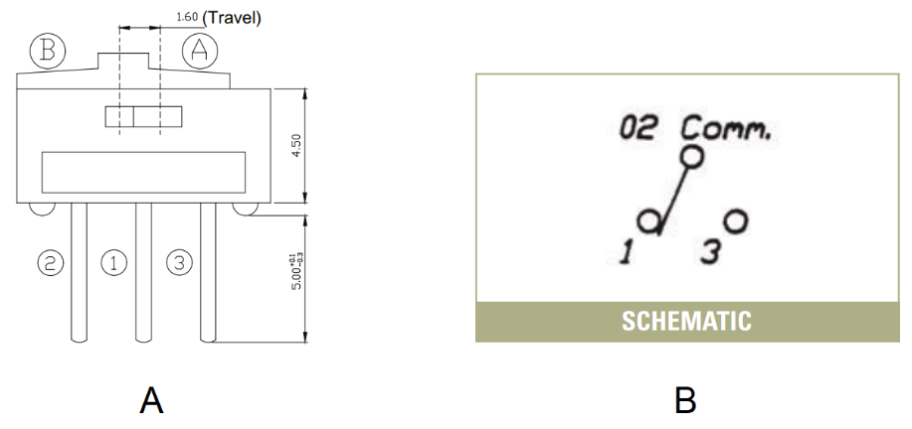

Figure : Switch operation as defined in the manufacture’s technical documents.

**We are using part B for the Audio board.**

1. What is the maximum voltage and current that can be handled by the BJT curve tracer switch? Use the information posted on the Digikey parts page for this switch, , do not use the technical documents.

**The Digikey information page states that the switch is rated for a maximum of 24V and 300mA.**

1. What is the maximum voltage and current that can be handled by the Audio board switch? Use the information posted on the Digikey parts page for this switch, , do not use the technical documents.

**The Digikey information page states that the switch is rated for a maximum of 30V and 200mA.**

1. In Figure 4A, what pair of terminals are connected when the actuator is in position B?

**Terminals 1 and 3 are connected when the actuator is in position B.**

1. Do the manufacture technical documents for the switch in Figure 4B, make it clear what pair of terminals are connected together when the actuator is in its left position?

**The manufactures technical documents do not clear identify which terminals are connected together for each actuator position.**

Now, let’s move on to the details of assembling your Audio board.

**Soldering Together the Audio Board**

Table : Complete the missing entries in the table of resistance color codes.

|  |  |  |  |  |
| --- | --- | --- | --- | --- |
| Value | Band 1 | Band 2 | Band 3 | Band 4 |
| 100 | Red | Red | Brown | Gold |
| 1k | Brown | Black | Red | Gold |
| 2.2k | Red | Red | Red | Gold |
| 10k | Brown | Black | Orange | Gold |
| 100k | Brown | Black | Yellow | Gold |